<https://www.youtube.com/watch?v=9QUM5jtB0t4&t=1078s>

Unsupervised learning

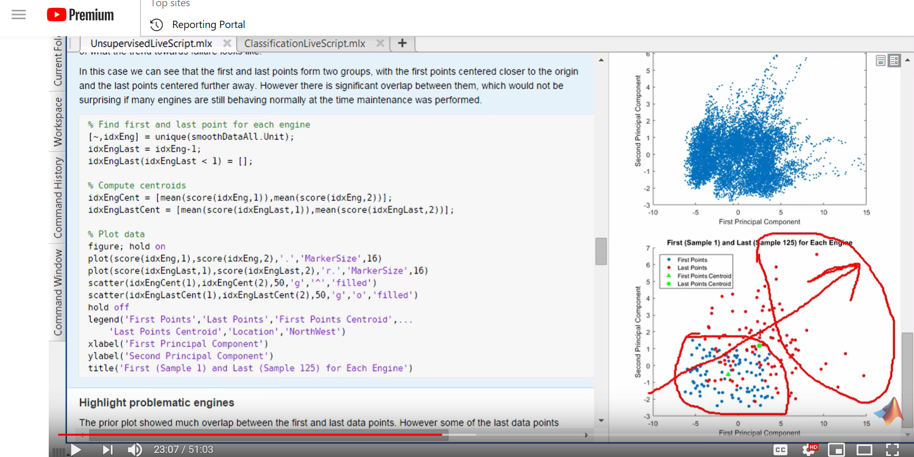

Look at the trend above they know for a fact that the red points are points where engine is going for maintenance

We have this from a single day use of a truck

Going back to the example what they do is look at the problematic engines which they knew from their maintenance staff in the plot and see this trend :-

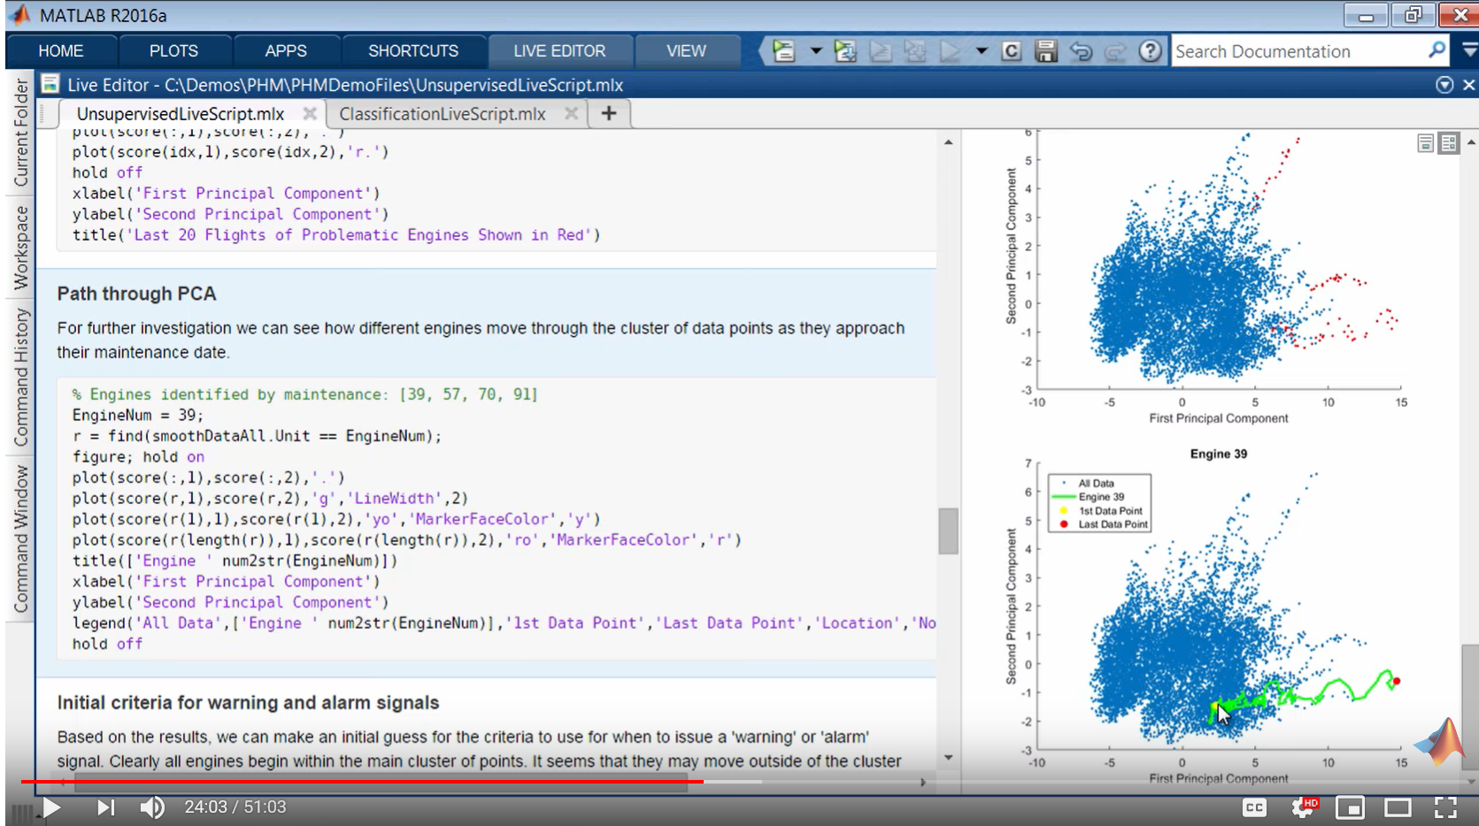

Supervised Learning

For supervised learning just classify the vibration into 5 sections small, moderate, extreme, urgent maintenance and failure

Each of the data point you have must fall into the above-mentioned classes.

There is no easy way where these fall into that’s why we take mean of each data.